Excerpt from Certificate IV Child Youth & Family Intervention – developed for residential care workers
Social Inclusion: Trainer’s notes
  - Overview of Social Role Valorisation (SRV) theory:
    - Who and what does our society value - people, stereotypes, qualities and attributes that society values. For example: actors, singers, musicians, socialites, wealthy, healthy, employed, attractive, clever, intelligent, good communication skills, competence, independence, own homes, well dressed, good hygiene, etc
    - Who by contrast does society devalue. These should be the opposite to what was listed above. For example: people with disabilities, poor, homeless, poor personal presentation, dirty, smelly, etc
    - People who have characteristics that are not highly regarded, become devalued themselves
    - Group discussion on young people in care and how they are potentially viewed in society. For example: their behaviours, criminal conduct, lack of: education; wealth; possessions; housing; grooming; hygiene presence of others who care and support;
    - Devalued people are controlled by society in that they
      - Can have no say – discuss and reflect on YP
      - Are kept dependent (on welfare, organisations, services providers, etc)
      - Are moved around – reflect on YP and Indigenous people
      - Are segregated
      - Lose their identity
      - Lose relationships that are not based on wage provision
      - Lose connections to places, people; and possessions
      - Judged
      - Stereotyped
      - Excluded / Rejected
      - Additional group responses
    - People who are valued in society are included and have access to “the good things” in life, like love, friendship, respect, employment and the chance to develop their abilities. “The good things” in life are things that should be accessible to all people.
    - People who are devalued in society not only have the cause of their devaluing to overcome, but they are also subjected to stereotyping, judgement, exclusion, rejection.
    - They are also subject to other’s low expectations, and as people often act in the way that people expect them to – self-fulfilling prophecy causes them to internalise the worthlessness and live down to those expectations. This is a vicious cycle that continues to spiral down.
    - We need to focus heavily on reducing the number of ‘bricks’ on our young people’s backs and actively compensating in areas that can be strengthened. Bricks are the devalued characteristics and societies reactions to these – discuss what may be some ‘bricks’ on young person’s back (workbook page 91).
    - A definition of SRV: “The application of what science can tell us about the enablement, establishment, enhancement, maintenance, and/or defence of valued social roles for people" (Wolfensberger, 1995a).
    - SRV is about increasing opportunities for devalued people by assisting the development of valued social roles in society – the more roles a person has and the more valued those roles, the more valued the person and the more likely that they have access to the good things in life.
    - If an individual can hold even one valued social role in society, they have a better chance of participation, inclusion, development of relationships and accessing the other good things in life. If an individual can access these things, the whole quality of their life improves.
    - Give participants 5 minutes to write down all the roles they have in workbooks. For Example: youth worker, mother, brother, daughter, friend, nephew, aunty, gardener, student, teacher, shop assistant, customer (of hairdresser, post office, bank, corner store, etc) neighbour, snorkeler, fisherman/woman etc. Have participants call out and list on whiteboard (workbook page 94)
    - Discuss the elements, impact and value of these roles for individuals (refer workbook)
      - What do they give you? For Example: sense of accomplishment, self-identity, social identity, status, competencies, sense of belonging, autonomy, growth, freedom, relationships,: gained; maintained; strengthened, etc
      - How do you know you are filling a valued role? For example: where, with whom, what is done (including objects and materials used_, what person looks like (“uniform”?), how person is spoken to and about, etc. Ask group for examples of the above for: a police man, a basket-baller, a student, etc.
      - How do you develop positive, valued roles? Discuss. For example: existing relationships, who you know, what you currently do, interests, talents, passions, etc. Start as early as possible and focus on developing maintaining YP’s competencies – focus on their strengths – take a strengths based approach. More on this later. Emphasise the importance of using typical, ordinary means.
      - Just as devaluation can become a downward spiral, developing and maintaining competence and socially valued roles can be an upward spiral. Participation and relationships strengthen valued roles and bring about new / more valued roles. Discuss.
  - Activity 20: 15 mins What does “the good life” look like?...
    - Instructions:
      - Working individually (pages 95-98) using 3 drawn circles, participants are to allocate sections of each circle like a pie chart dependant on the amount of time they spend:
        - with various people in their lives (EG: partner, family, flatmate, friends, etc);
        - in various places (EG: work, home, cafe, gym, bar, friend’s house, park etc); and
        - doing various pastimes (EG: work, sleep, hobbies, sport, visiting, dining out, movies, jobs/chores, reading etc)
      - Discuss participants’ allocations. For example: in Pastimes, we spend on average 1/3 of our time sleeping and approximately 1/3 of our time engaged in work activities, what did participants have for the rest. Also get input for people and places. Ask participants to reflect on what you get out of each of these allocations and share with the group.
  - Activity 21: 15 mins What does your young person’s life look like
    - Instructions:
      - Working individually participants are to allocate sections of each circle like a pie chart dependant on the amount of time their young person spends:
        - with various people in their lives (EG: family, youth worker, co-tenant, friends, girl/boyfriend, counsellor etc);
        - in various places (EG: school / TAFE, home, shops, gym, park etc); and
        - doing various pastimes (EG: work, sleep, hobbies, sport, visiting, dining out, movies, jobs/chores, reading etc) (Workbook pages 99-102)
      - Discuss any similarities and differences between YP’s and participant’s allocations for own life. For example:
        - Are there any significant differences in quantity and quality of people / relationships in young person’s life? How many people take up the YP’s “people” circle who engage with the YP in paid roles. Discuss the perception the YP may have of the ‘paid’ relationships in their life. Discuss the impact of paid relationships generally not being persevering. Who will fill the spaces left when the paid relationships end?
        - Discuss observations of Places YP spend their time
        - Discuss observations of YPs current Pastimes and activities
  - Activity 22: 10 mins Guided dreaming into the future:
    - Instructions:
    - Have participants sit back, relax (turn chair around or sit on floor if they wish), close their eyes, and visualise the following:
    - You are some time in the future. You are happier than you have ever been in your life. Happier than you ever thought you could be. You are completely fulfilled and spend your days doing all that you love.
    - Make a note to yourself what date it is?
    - Let yourself take a really good look at what is happening on this day in your dream. Where are you? What’s around you? Who is there? What are you doing? How do you know you’re happy? How do you spend your time? What are you looking forward to?
    - Tell participants to take a deep breath, remember what day it is today and open their eyes
    - Prompt participants to write notes in workbooks on ideas to use with young person discussed next
    - Participants to take notes (activity 22 p 105) - Discuss using something like this strategy with the young person to discover their passions. Or asking them to write down an “All the things I love” list. Brainstorm and whiteboard other strategies (refer to Handout – All the things I love and Roadblocks to dreaming” from Developing Leisure Identities).
    - Discuss what are some blocks to “dreaming” (refer to Handout – All the things I love and Roadblocks to dreaming” from Developing Leisure Identities)
  - Share stories and or read through stories of young people and adults being supported to tap into a passion, interest, talent, gift or even challenge and the development of capacity and valued social roles that resulted. Resources: Robbie Gilligan 1999 article; Developing Leisure Identities, Judith McGill, 1996; or known stories about young people -young person currently in one of our zones was having a very rocky time in care, including with school – was hardly attending. Was absconding and engaging in high risk and illegal activities. Teachers at that school were able to mentor her capacity to assist the teacher and others in the classroom using a particular topic of strength for her. She was voted Vice Captain of the school by her peers and teachers! Her attendance increased to 100% and her self esteem and sense of accomplishment and belonging were greatly boosted.

- Mapping out the social role: 20 mins
  - Why would it be beneficial to map out the role ( - to acknowledge and celebrate all the small steps and shifts in perception, participation, language used, behaviour, skills etc)? It’s a great planning, tracking and celebration tool for developing / development of social roles for the YP
  - Discuss strategies for mapping out this process using mind maps. This activity should include the whole team, including young person, family, stakeholders etc. Review the “fitness club member” mind maps slide (from Developing Leisure Identities, McGill 2006).
  - Slide 1 is a map of all the possible activities that could be through of around this interest
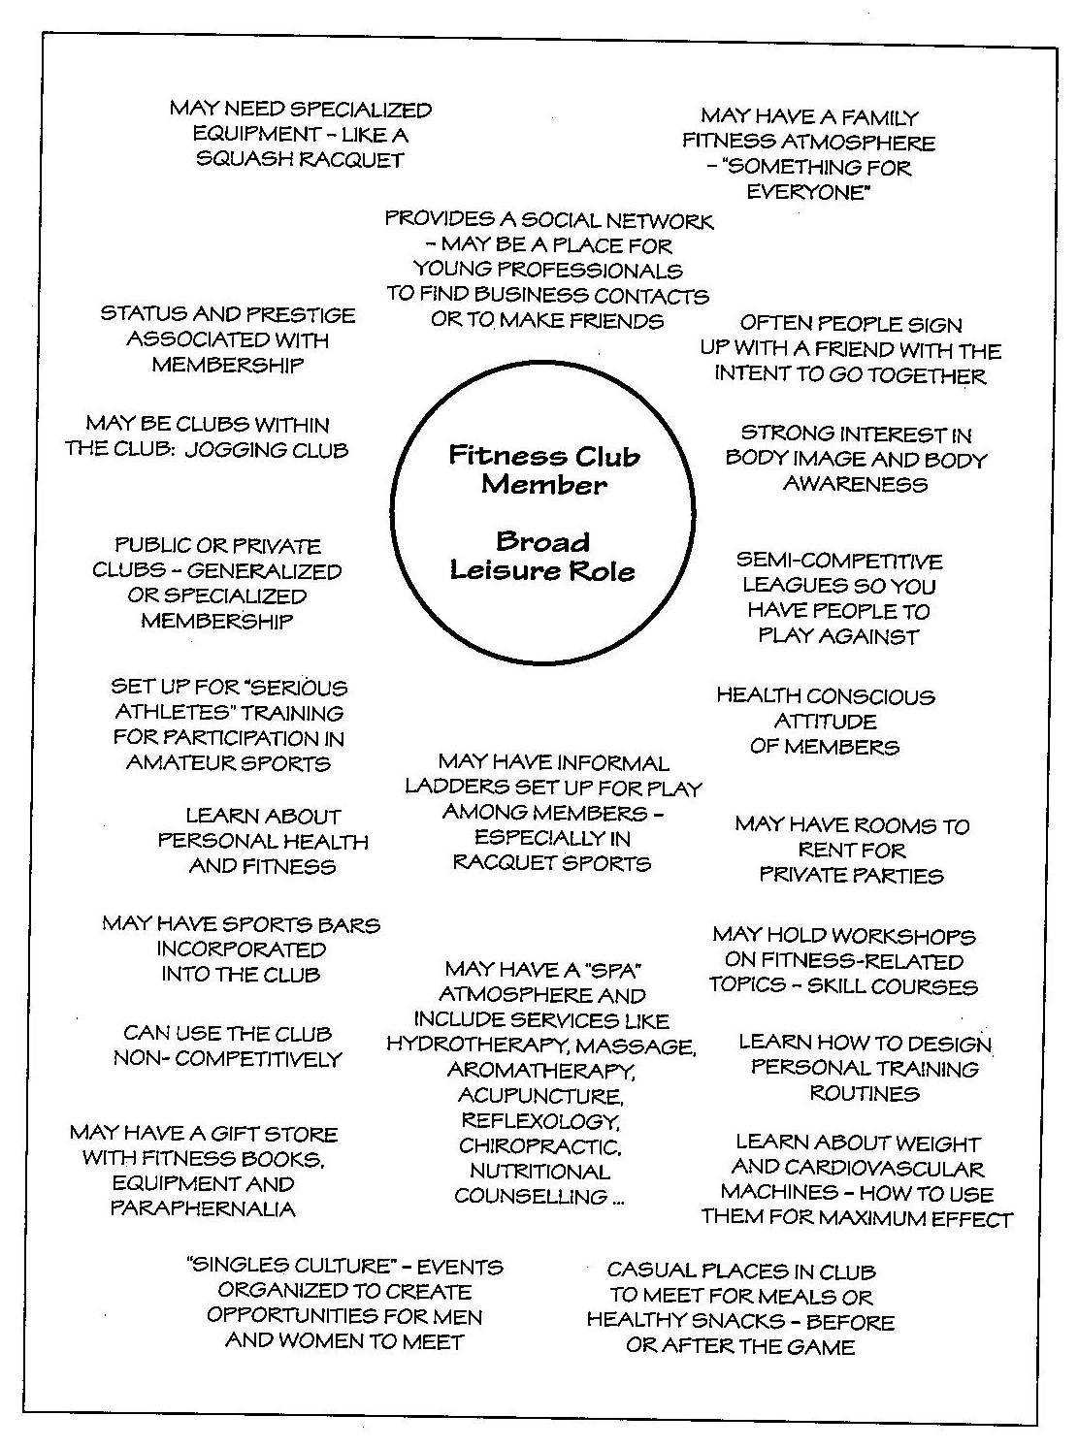

  - Slide 2 is the individual’s initial map of the role – how familiar they were, their perceptions of it and the possibilities

  - Slide 3 is an emerging identity map 2 months later – you can see the emergence of the person’s progression, taking on the identity, likes and dislikes, areas of development, developing relationships
  - Slide 4 is emerging identity map 3 months later

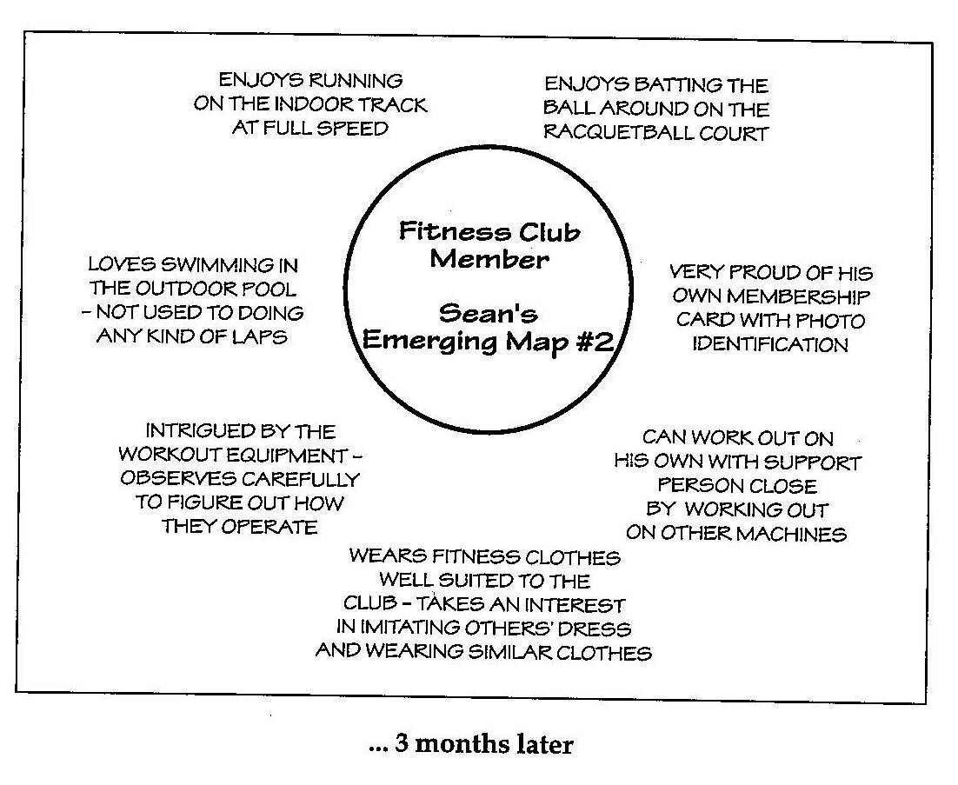
  - Slide 5 is emerging identity map 5 months later
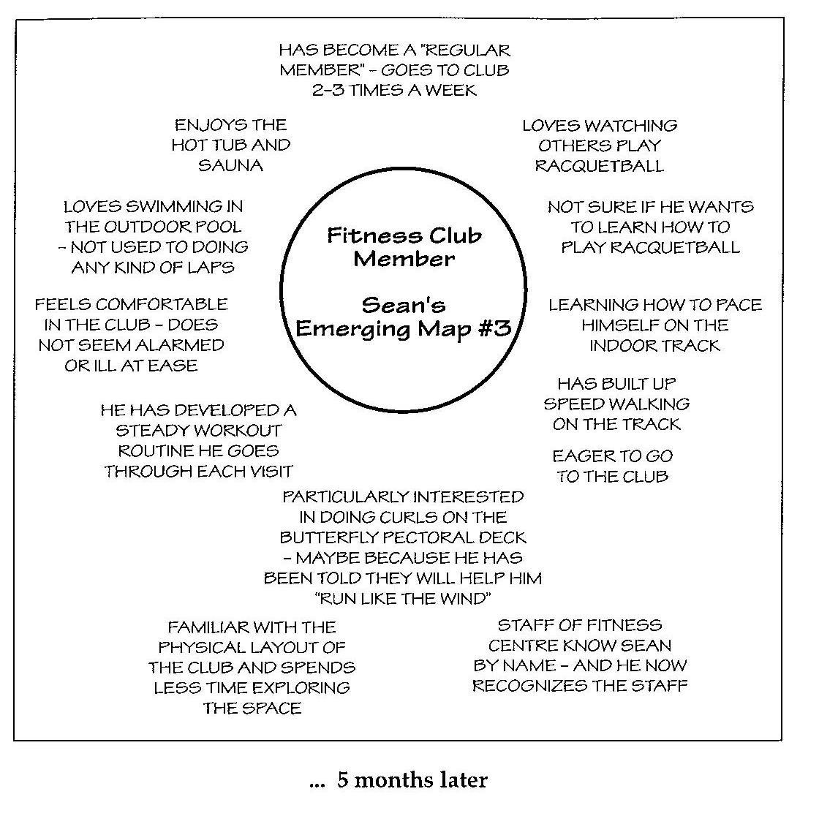
  - Slide 5 is emerging identity map 9 months later
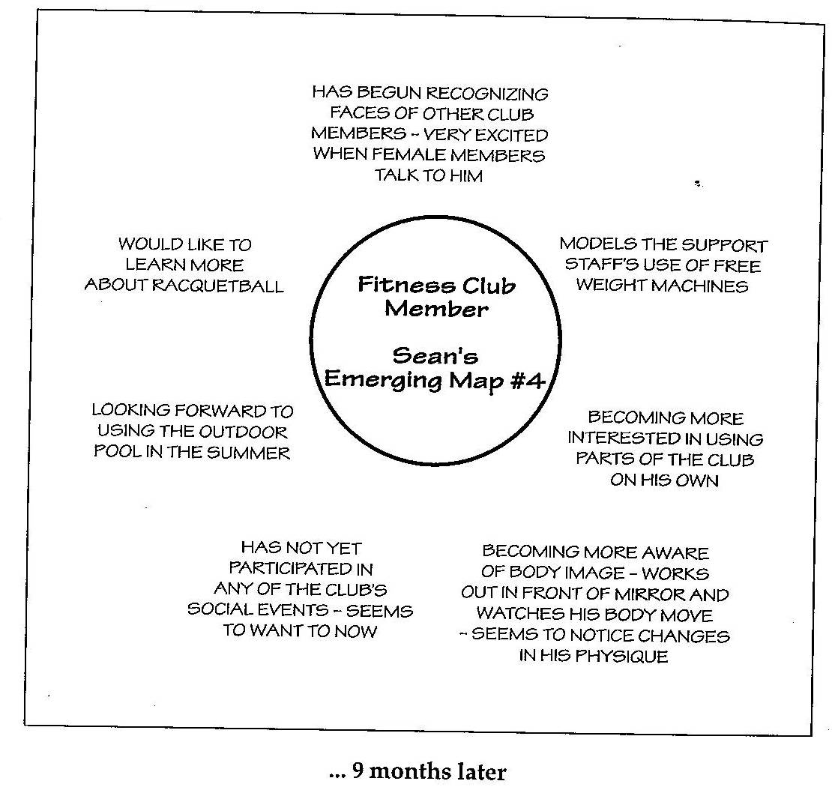

  - Slide 6 is snapshot identity map 12 months later

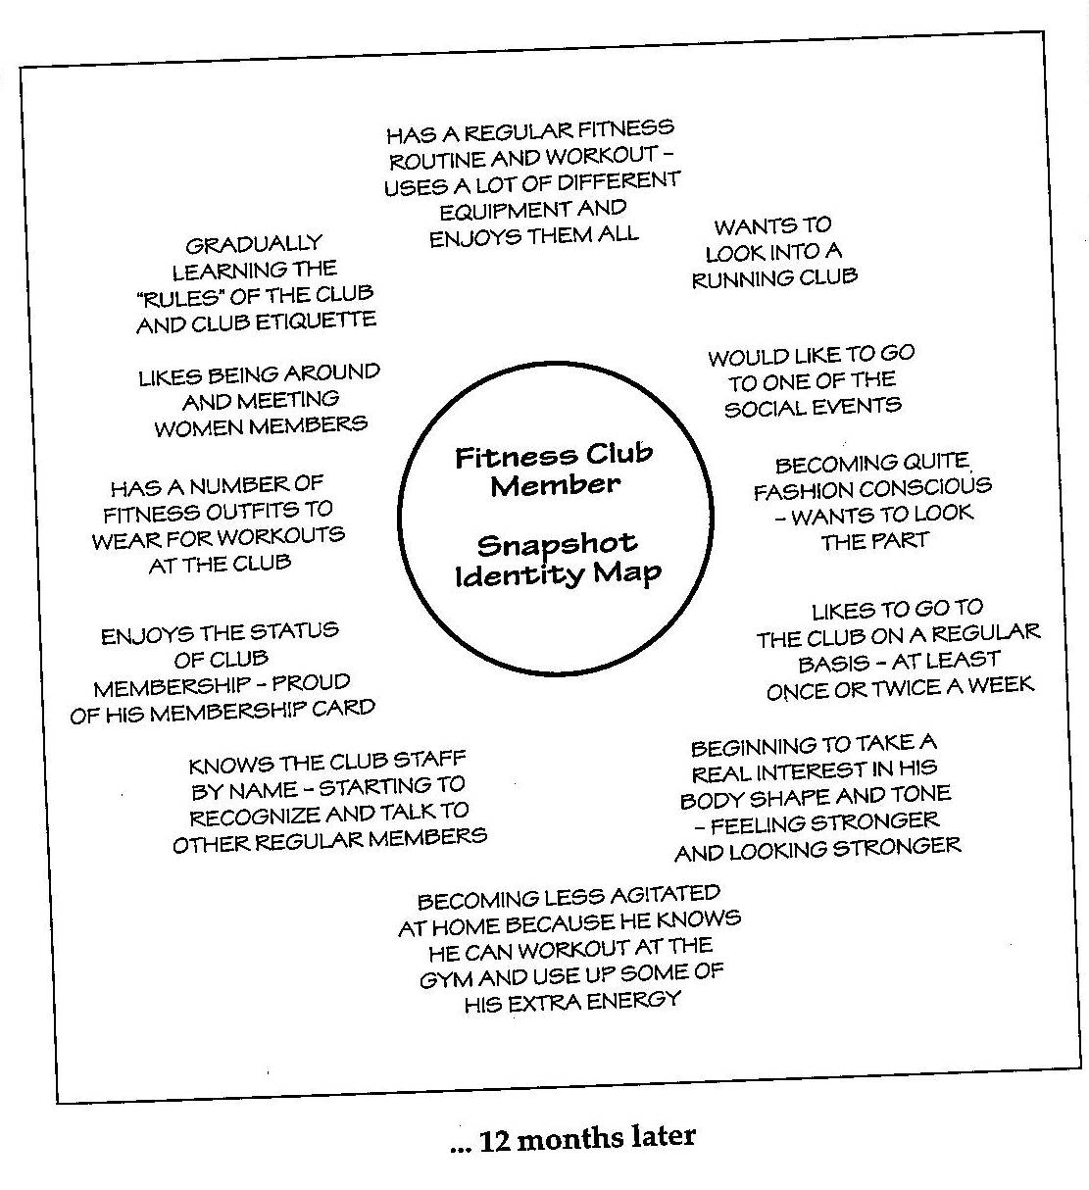
  - Activity 23: 60 mins
    - Instructions:
      - This activity will be similar to the process used in the Fitness Club Member example discussed earlier. Working in teams and using the youth work case study, participants are to:
        - Gather 4 pieces of flipchart paper and various coloured markers
        - Assign 1 team member to role play Jane as needed
        - Identify as many as possible of Jane’s passions, strengths, talents, interests by involving Jane
        - Mutually decide on 1 area of interest or strength
        - Develop an initial broad role mind map of all the possibilities (for anyone with any capacity) in this area of interest
        - Develop another map to depict where Jane is currently in relation to this interest
        - Develop a third map to detail all the possible areas of development the Jane and the team could focus on next
        - Draw 3 large circles on flip chart paper with the headings People, Places, Pastimes above each circle. Assume that these circles reflect 100% of the time Jane may spend engaged in this role / interest. Assign sections of each pie chart to reflect how Jane may spend time in relation to this role. For example in the people circle, identify all members of the community that Jane may be linked in with and therefore have opportunities to develop sustainable relationships with
        - Team to present work to larger group
        - Discuss how this activity could be incorporated into the Case Plan for the young person you support

